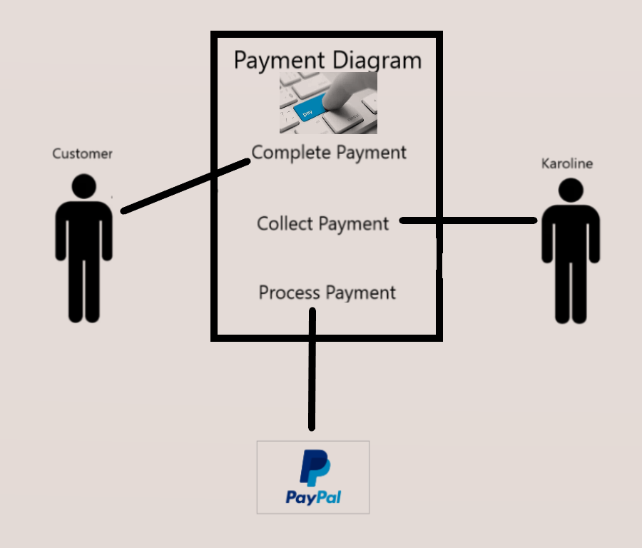

The Payment Process Diagram

The diagram shown above displays the use case and the parties involved in processing payments received by Sweet Karoline’s Cakes. The customer supplies their payment information to complete the order and the information is processed by PayPal. Sweet Karoline’s collects the payment at the end of the process.